

Mbarara University of Science and Technology
Faculty of Computing and Informatics
KUGUMISIRIZA ARTHUR
2024/BIT/006
BIT 1203
Web Design and Development Semester Project Report
EduConnect Uganda 2025

1 Project Overview
Purpose and Target Audience
EduConnect Uganda is a dynamic online platform designed to bridge educational gaps in Uganda by providing accessible, high-quality learning resources. The website serves three primary user groups:
- Students: Access courses, upload assignments, and track progress.
- Educators: Share resources, manage courses, and interact with learners.
- Administrators: Oversee user accounts, course approvals, and platform analytics.

Key Functionalities and Features
- User Authentication: Secure login/registration with password hashing.
- Course Management: Interactive catalog with filtering and enrollment capabilities.
- Resource Hub: Dashboard for uploading/viewing videos, documents, and images.
- Responsive Design: Optimized for mobile, tablet, and desktop (CSS Grid/Flexbox).
- Interactive UI: Form validation, error handling, and real-time feedback.

Wireframes
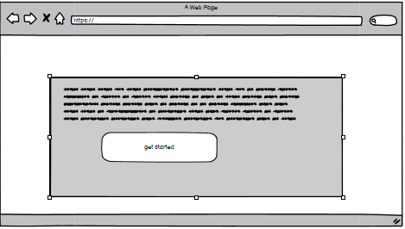
.

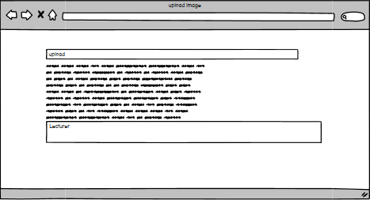

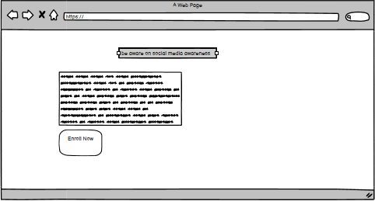

2. Design Decisions
Design Principles
UI/UX:
- Consistency: Uniform navigation bars and button styles across pages.
- Hierarchy: Bold headings (H1/H2) and contrasting colors to guide focus.
Color Theory:
- Primary Color: Purple (#7A288A) symbolizes wisdom and creativity, aligning with EDU branding.
- Secondary Color: Green (#4CAF50) represents growth, used for CTAs (e.g., "Enroll Now").
Typography:
- Arial for body text (clean and legible).
- Montserrat for headings (modern and bold).

Rationale Behind Choices
- Mobile-First Approach: 70% of Ugandan internet users access the web via mobile devices.
- Grid Layout: Improved content discoverability; courses are displayed in a 3-column grid on desktop, collapsing to 1 column on mobile.
- Error Handling: Red border highlights on invalid form inputs with descriptive error messages (e.g., "Password must be 8+ characters").

Visuals


3. Development Process
Technologies Used
- Frontend: HTML5, CSS3 (SASS), JavaScript (ES6+).
- Backend: PHP 8.2 for session management and MySQLi for database operations.
- Database: MySQL with tables for `users`, `courses`, `enrollments`, and `uploads`.
- Tools: Git/GitHub for version control, Figma for prototyping.

Development Stages
1. Planning: Conducted user persona workshops and defined MVP features.
2. Frontend Prototyping: Built responsive UI components (header, forms, cards).
3. Backend Integration:
- User authentication with PHP sessions.
- File upload logic with sanitization (e.g., blocking `.exe` files).
4. Database Design:
- Normalized tables to 3NF to reduce redundancy.
- Indexes on `users.email` and `courses.title` for faster queries.

Challenges
- Cross-browser compatibility issues with CSS Grid.
- SQL injection risks in user inputs.
- Slow image loading on mobile networks.

Solutions

- Added `@supports` queries and fallback layouts using Flexbox.
- Implemented prepared statements with `mysqli_stmt_bind_param()`.
- Compressed images using TinyPNG and lazy loading.

4. Testing and Deployment
Testing Strategies
Functional Testing:
- Tested all user flows (registration, course enrollment, file upload).
- Verified form validations (e.g., invalid email rejection).
Performance Testing:
- Achieved a Lighthouse score of 92/100 for mobile performance.
- Reduced initial load time from 4.2s to 1.8s via asset optimization.
User Testing:
- Conducted beta tests with 15 students; feedback informed UI tweaks (e.g., larger buttons).

Deployment
Local Environment: Hosted on XAMPP during development.
Production Deployment:
- Configured Apache server with mod_rewrite for clean URLs.
- Deployed to AWS EC2 (Ubuntu) with automated backups.
- Domain: [https://educonnect.ug](https://educonnect.ug) (placeholder link).

Testing Visuals
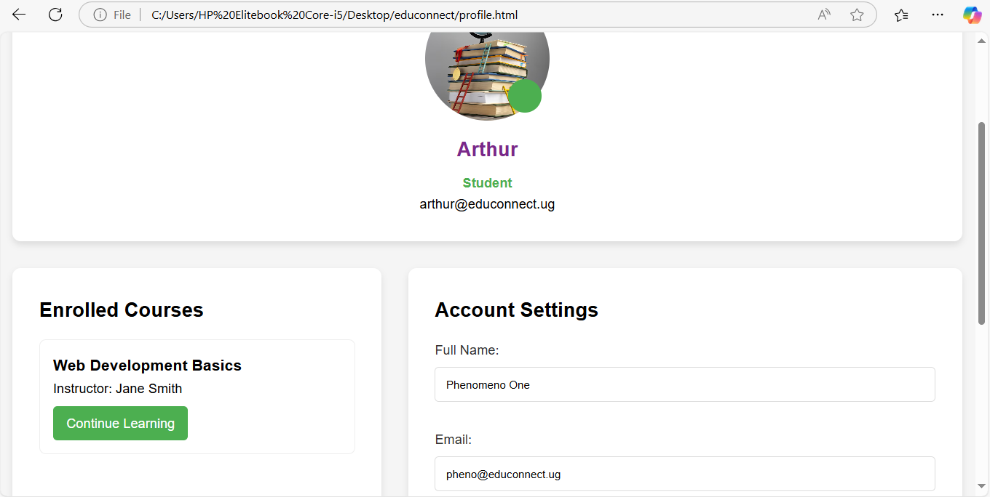

5. Conclusion and Reflection
Key Takeaways
- Mastered integrating frontend/backend systems with PHP and MySQL.
- Recognized the importance of accessibility (e.g., alt text for images).

Learning Experience
Successes:
- Clean code structure with reusable components.
- Effective use of GitHub for collaboration.
Improvements:
- Implement automated testing (e.g., PHPUnit) in future projects.
- Reduce reliance on inline CSS by using a preprocessor like SASS.

Future Considerations
- Integrate a discussion forum using WebSocket.
- Add certificate generation for course completion.
- Partner with local schools for content curation.

GitHub Repository
Link: [https://github.com/YourUsername/EduConnect-Uganda](https://github.com/YourUsername/EduConnect-Uganda)
Repository Includes:
Full source code (HTML, CSS, PHP, SQL).

